PromptIQ – Intelligent LLM Evaluation & Prompt Optimization Platform
it combines three important GenAI concepts:
- LLM Evaluation
- Prompt Engineering and Optimization
- LLM-as-a-Judge

What PromptIQ will do
A user enters a prompt, and the platform generates an LLM response. An evaluation engine assesses that response across five quality dimensions, identifies its weaknesses, and generates an improved prompt.
The system then executes the improved prompt and compares both responses using evaluation scores.
Evaluation : Metric, Accuracy, Relevance, faithfulness, clarity, completeness
Complete technology stack
I recommend keeping the stack relatively simple. You don't need to introduce too many technologies into the first version.
Component | Technology | Purpose
Programming | Python | Main development language
Frontend | Streamlit | Interactive dashboard
Backend | Python | Application logic
LLM API | Groq API | Generate responses
LLM Model | Llama 3.3 70B Versatile | Response generation and judging
Evaluation | DeepEval | LLM evaluation
Evaluation metrics | Custom LLM-as-a-Judge | Five quality dimensions
Prompt refinement | Groq API | Improve original prompts
Data processing | Pandas | Score comparison
Visualization | Plotly | Evaluation charts
Environment | Python venv | Dependency management
Version control | Git & GitHub | Project management

How will the five evaluation metrics work?
This is an important part of your implementation.
Metric | What it evaluates | Evaluation method
Accuracy | Factual correctness | Reference answer or judge
Relevance | Whether the answer addresses the prompt | LLM judge
Faithfulness | Whether claims are supported by provided context | Context-based evaluation
Clarity | Whether the response is understandable | LLM judge
Completeness | Whether all requested aspects are covered | Requirement-based evaluation

1. Accuracy
Checks whether the generated information is factually correct.
Example:
Question: Who developed Python?
Response: Python was developed by Guido van Rossum.
Accurate
2. Relevance
Checks whether the response actually addresses the user's question.
Question: What is Python?
Response: Python is a programming language.
Relevant
Response: Java is another popular programming language.
Not relevant enough
3. Faithfulness
Checks whether the generated response is supported by the provided reference context.
Example:
Reference context:
"Python was created by Guido van Rossum and first released in 1991."
Response:
"Python was created by Guido van Rossum in 1991."
Faithful
Response:
"Python was created by James Gosling in 1995."
Not faithful
Important distinction: Faithfulness is particularly useful in RAG applications, where retrieved documents provide the evidence. A normal PromptIQ prompt without reference context cannot meaningfully establish source faithfulness. We will need to handle this distinction in your design.
4. Clarity
Checks whether the response is easy to understand.
Example:
Clear: Python is a programming language used to build applications.
Unclear: Python constitutes an interpreted computational language paradigm facilitating multifaceted execution.
5. Completeness
Checks whether the response covers the important parts of the user's request.
Question: Explain Python and mention two advantages.
Incomplete response: Python is a programming language.
Complete response: Python is a programming language. Its advantages include simple syntax and a large collection of libraries.
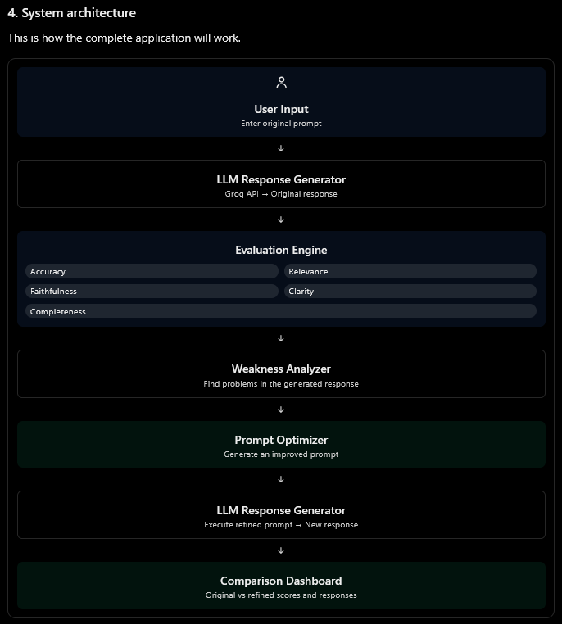
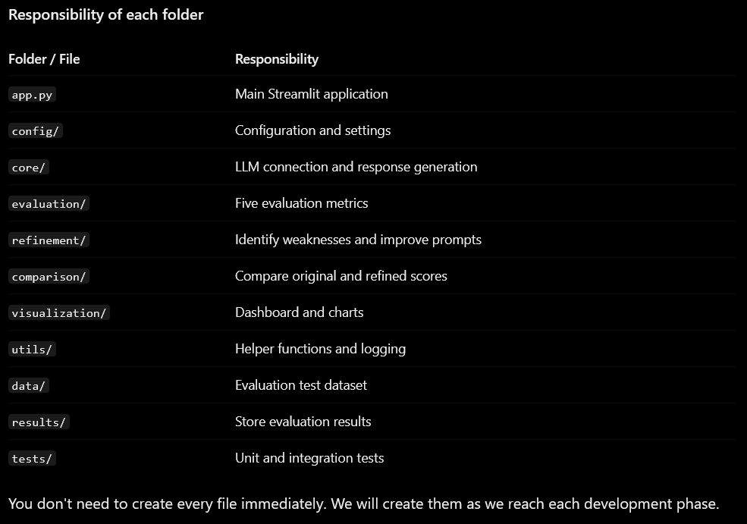

Phase 3: LLM Evaluation Engine
Here LLM-as-a-judge will work like this
our evaluator needs to send two types of messages:
- System message: Instructions telling the judge how to evaluate.
- User message: The prompt, generated response, and evaluation information.
System message tells the LLM HOW to behave.
User message tells the LLM WHAT to evaluate.
Custom LLM-as-a-Judge
Role: Acts as an evaluator for your generated LLM response.
- Receives the prompt and generated response.
- Evaluates five dimensions.
- Assigns scores (0–10).
- Explains weaknesses.
- Returns structured JSON.
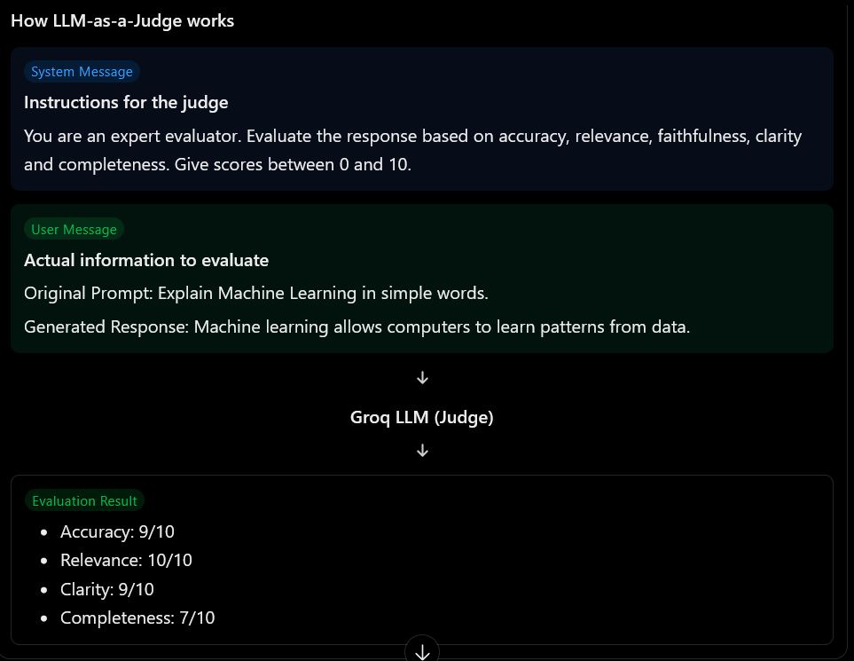
In simple words: We build our own AI evaluator using Groq API.
DeepEval Integration using G-Eval
Role: Uses the DeepEval framework to evaluate LLM responses against custom evaluation criteria.
- Creates evaluation test cases.
- Defines custom evaluation criteria.
- Uses G-Eval to judge response quality.
- Generates evaluation scores.
In simple words: We use an existing evaluation framework to perform structured LLM evaluation.
How will G-Eval work?
Suppose the user asks:
"Explain RAG in AI with a practical example."
The LLM generates an answer.
We provide G-Eval with:
- Input: Original user prompt.
- Actual output: Generated response.
- Evaluation criteria: What makes a good answer?
- Evaluation steps: How should the judge evaluate it?


